**IBM GuruCool FDP**

Project on

**Chatbot to shop for essentials during pandemic using Watson Assistant**

1. Registered and selected “chatbot to shop for essentials during pandemic using Watson Assistant” IBM project at smartinternz.com.

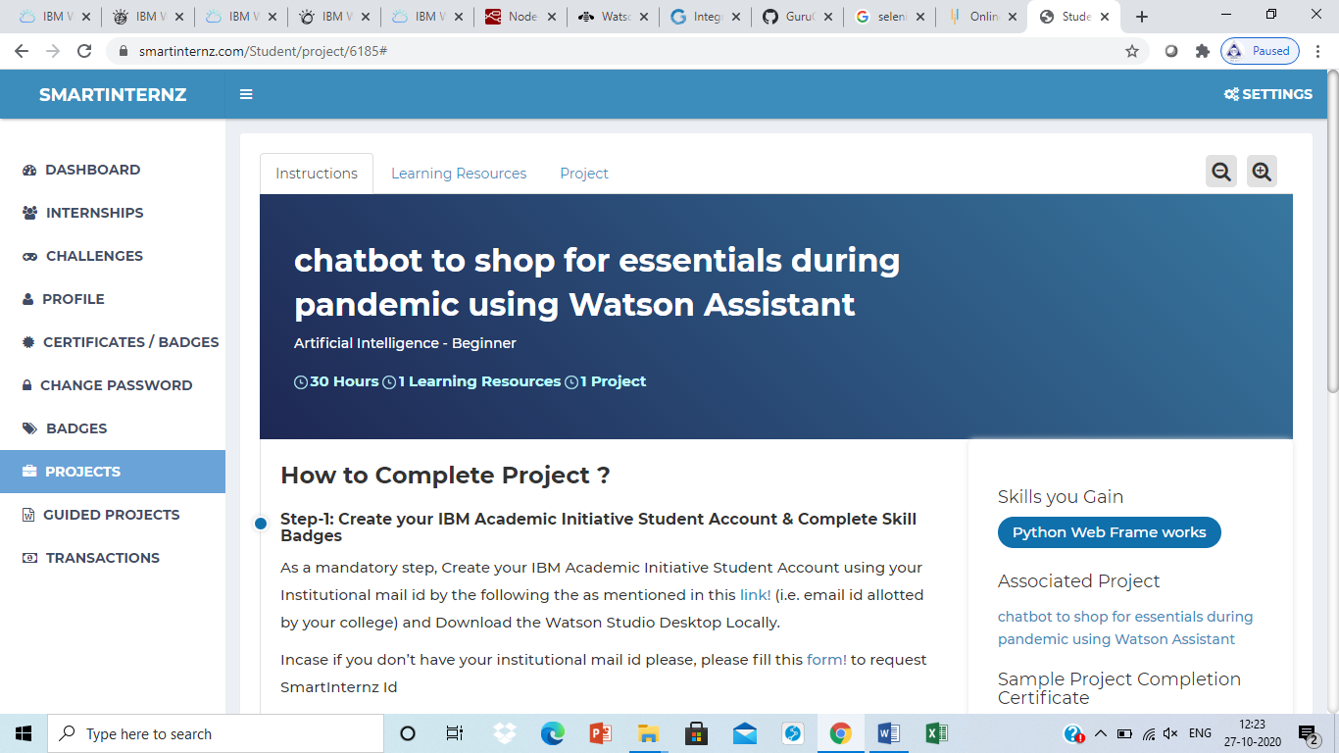

1. Login to IBM account.
2. Services used for project.

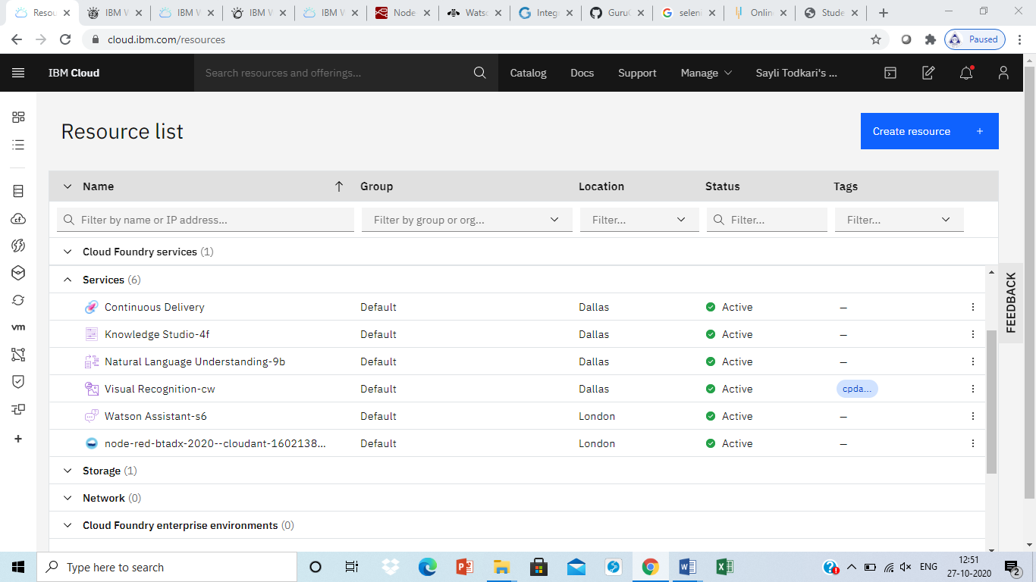

1. Launch Waston Assistant and create Intents, Entities and Dialog.

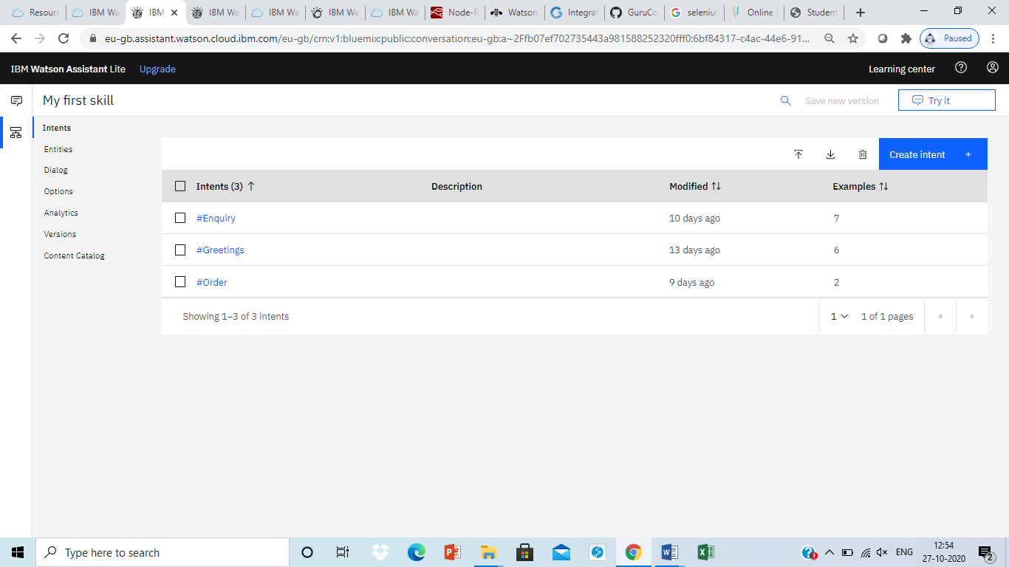

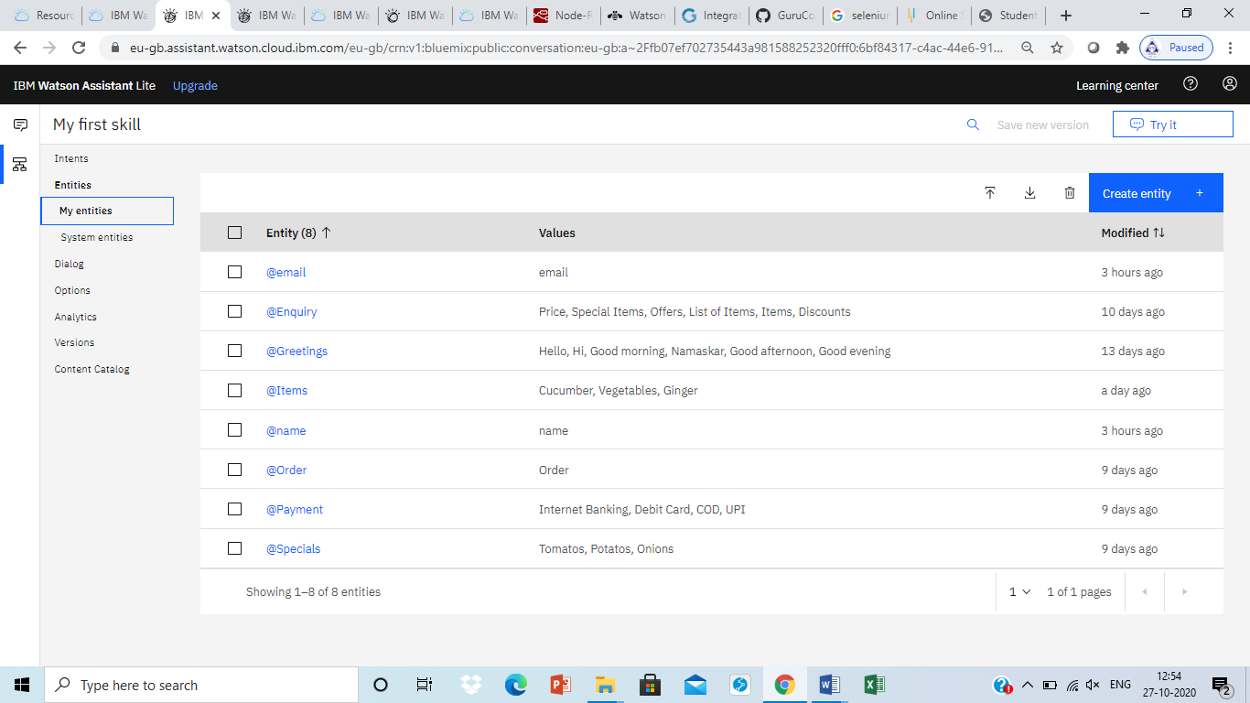

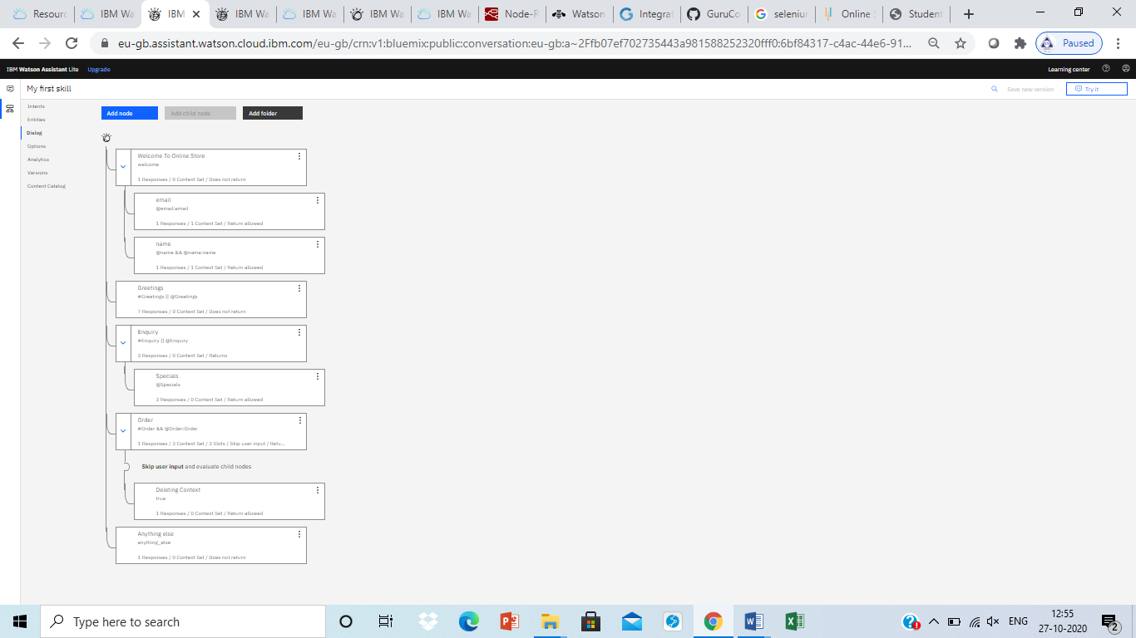

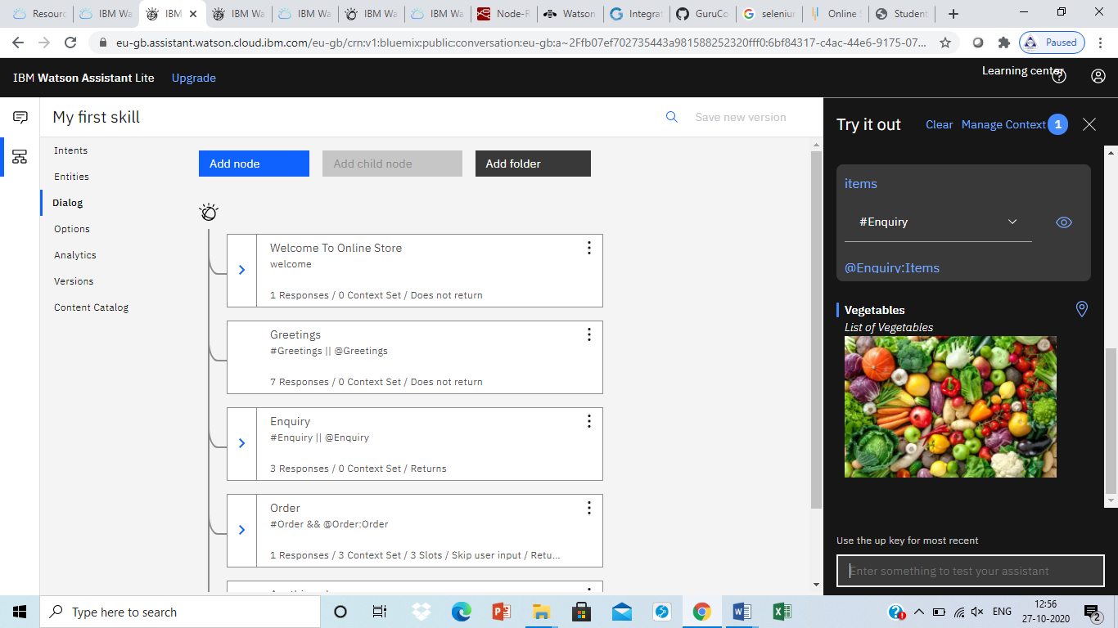

1. Create Natural Language Understanding and Node-Red

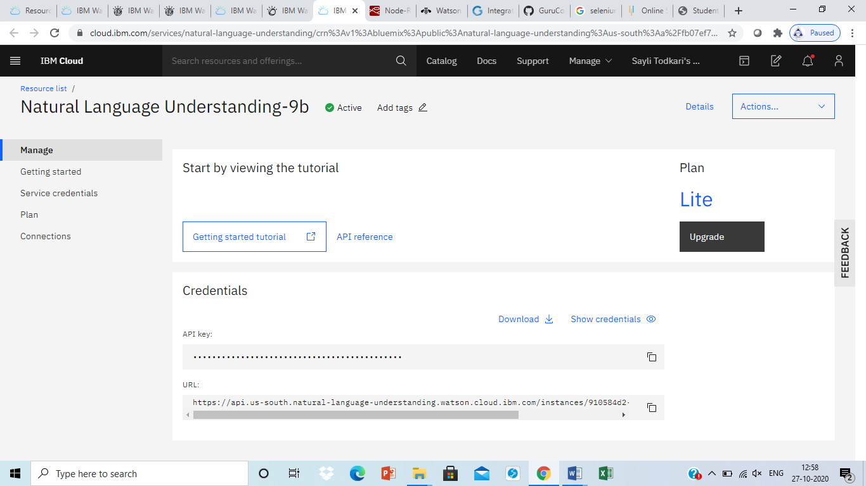

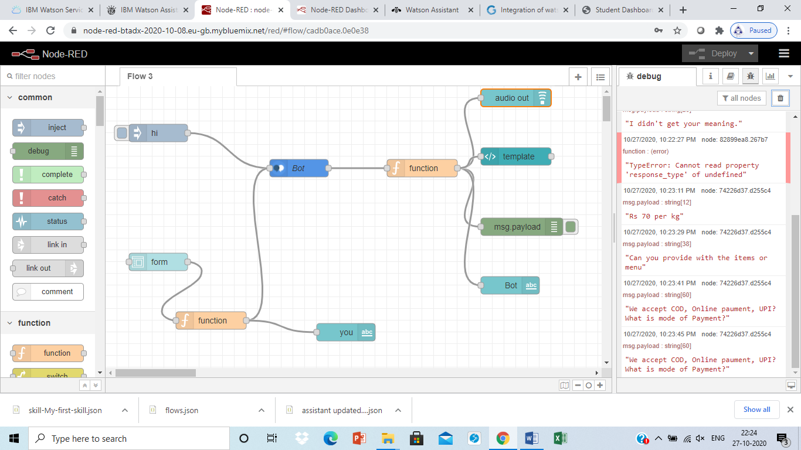

1. Web application of chatbot. Gave the sample inputs, click on submit and observe the Bot response.

Greeting message: 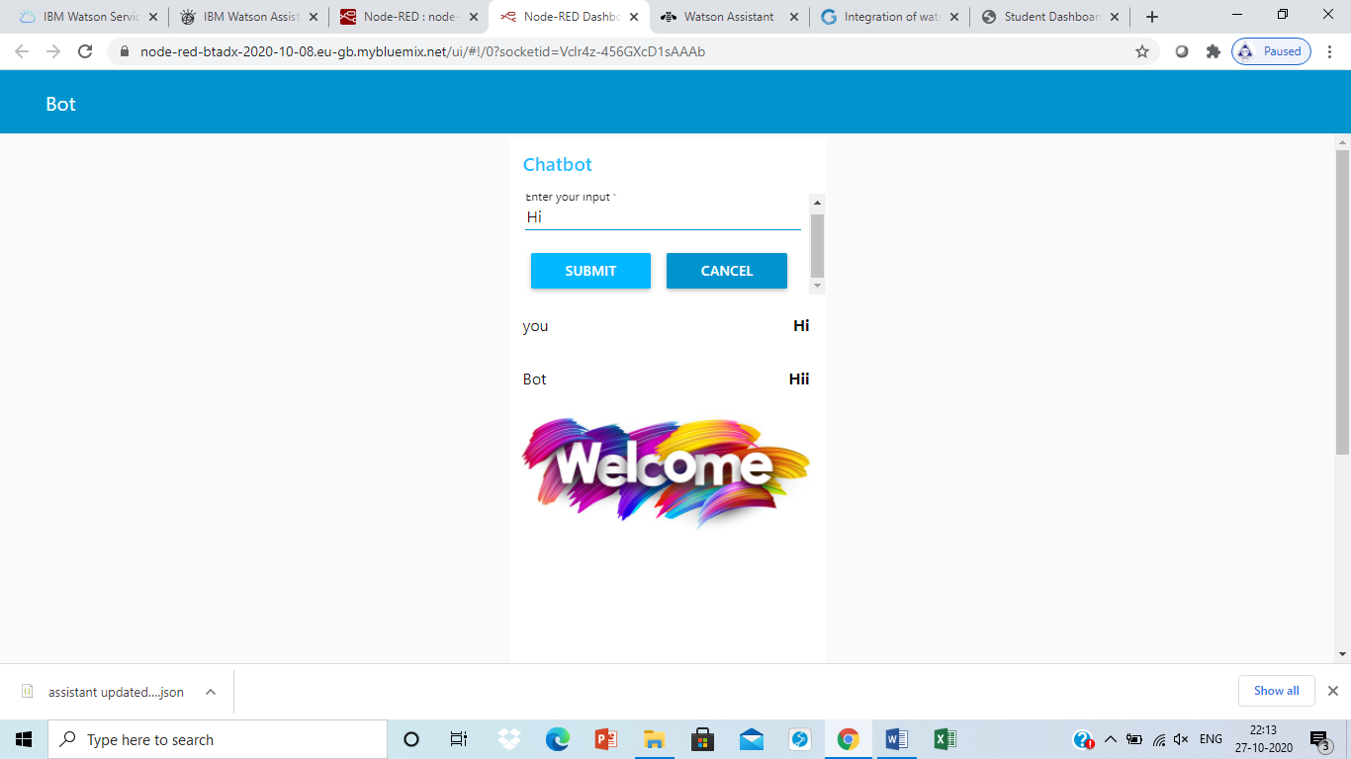

Placing order:

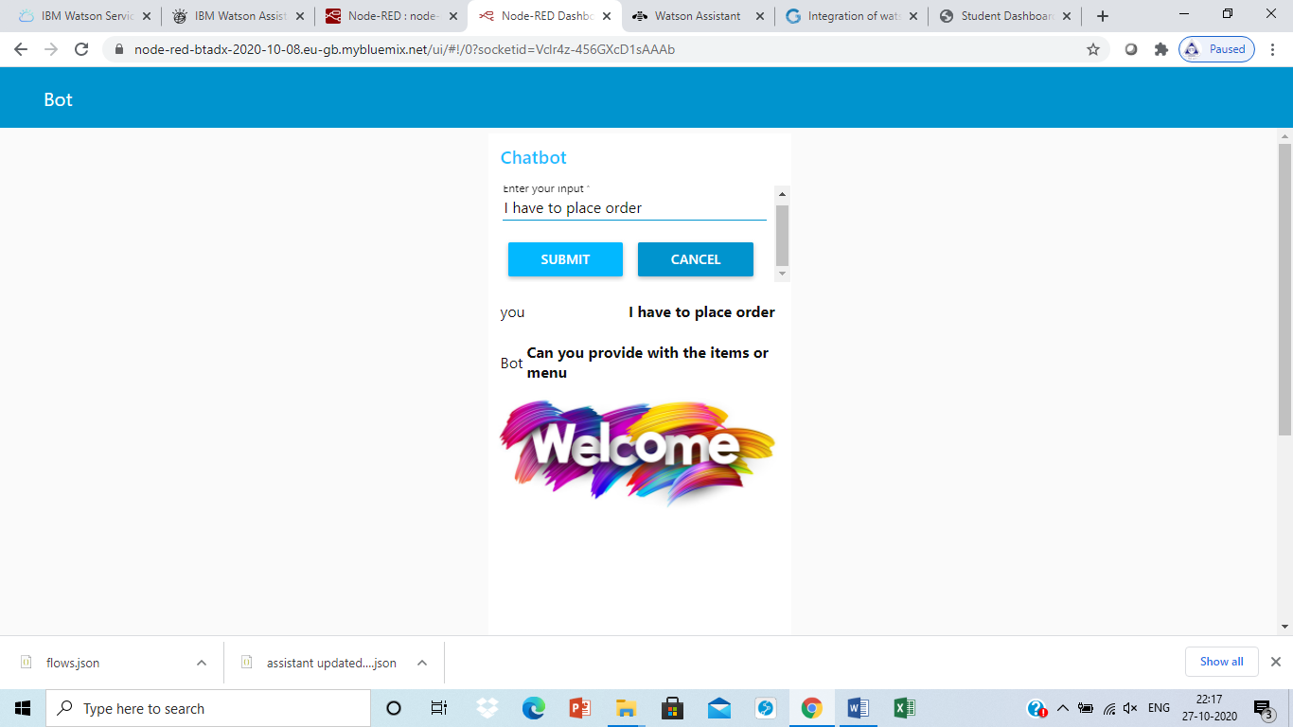

Available Items:

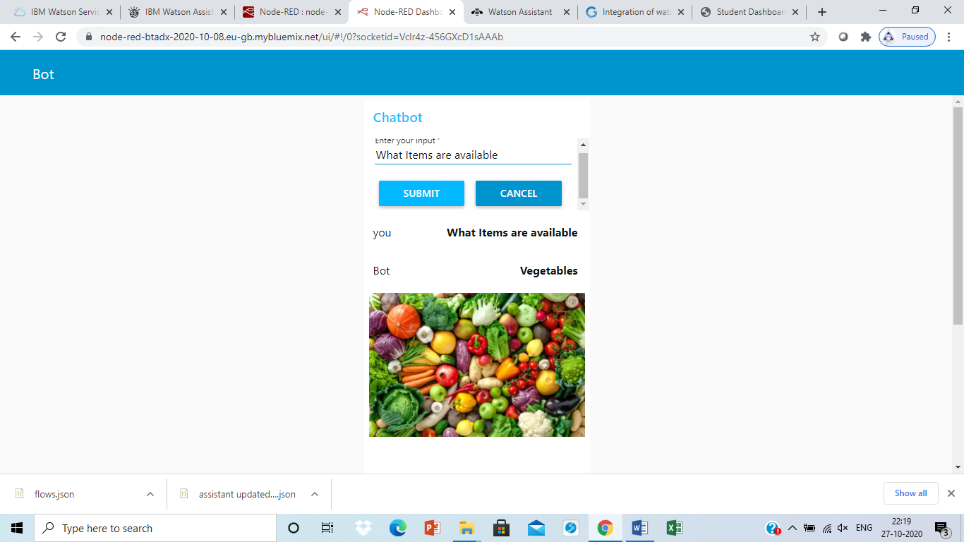

Place order of one item:

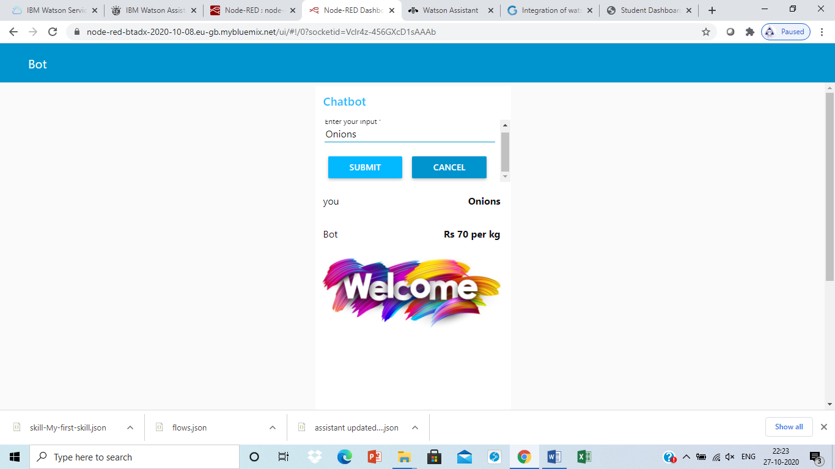

Offers:

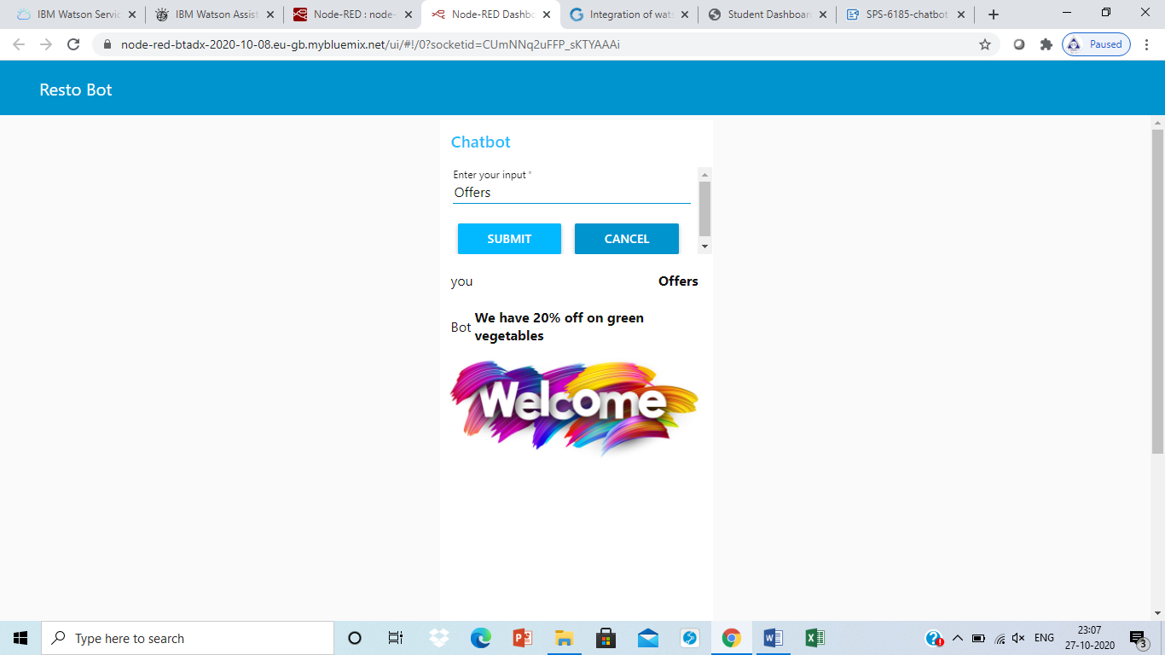

1. **Chatbot preview link:**

<https://webchat.global.assistant.watson.cloud.ibm.com/preview.html?region=eu-gb&integrationID=89307994-0339-4623-95e2-d99b9408be5a&serviceInstanceID=6bf84317-c4ac-44e6-9175-0742c095a90f>

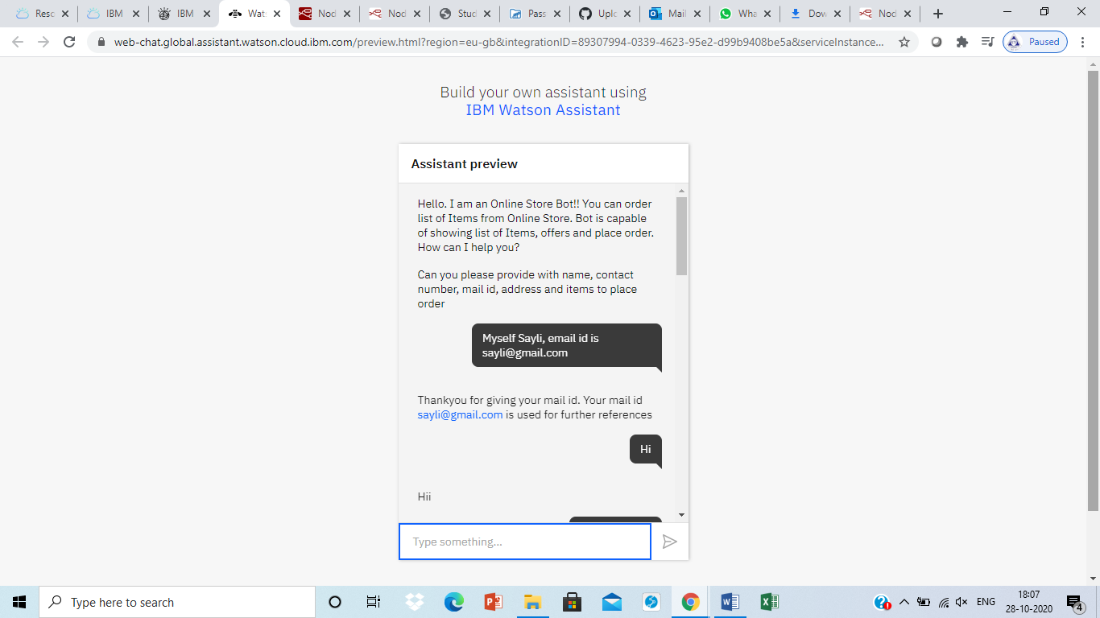

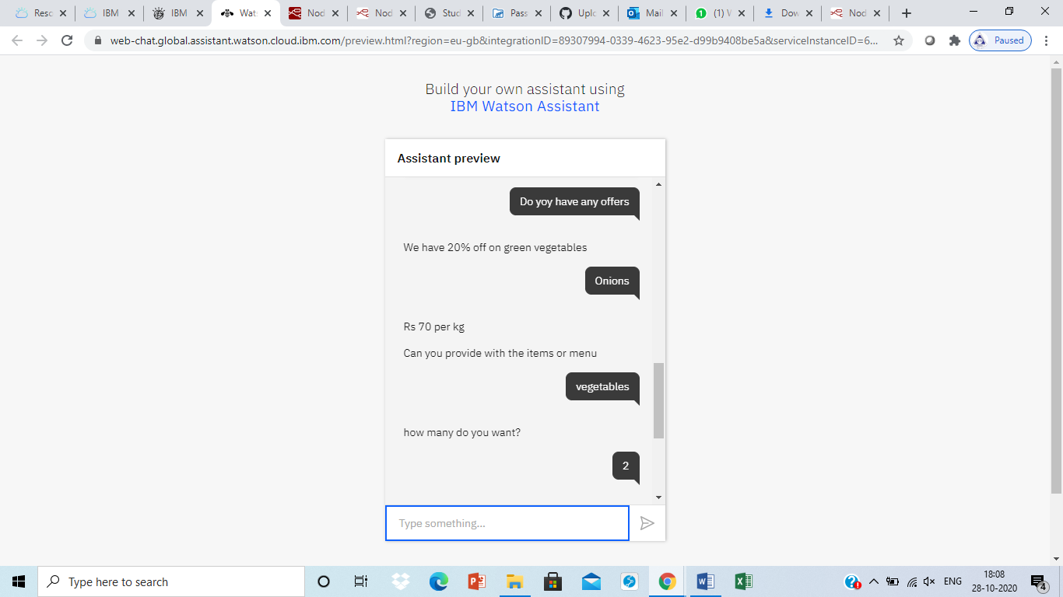

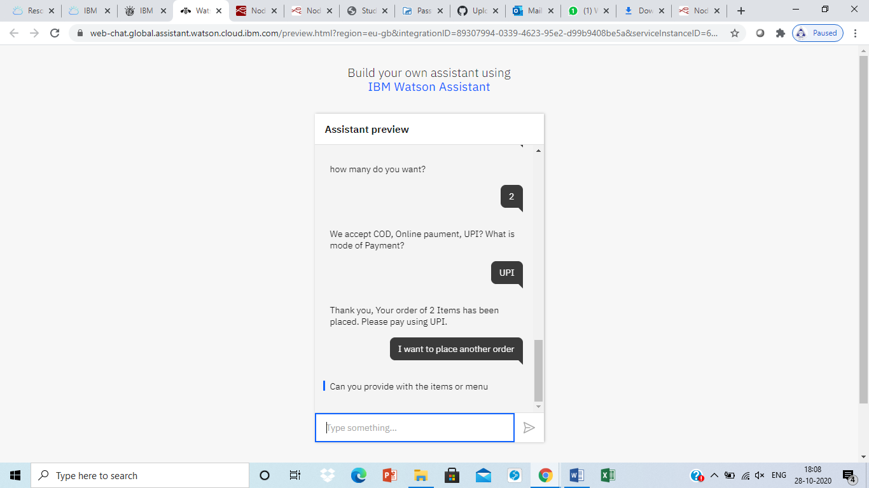

Report by,

Sayli Todkari

Assistant Professor

VIT, wadala